**SURYA.K**

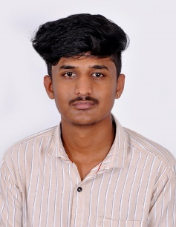

Email id:suryakumar11520@gmail.com

Mobile Number:7604848427

PROFILE

Hard working student seeking employment. I am ready to utilize my skills and passion for furthering companies mission. Technologically adept, Offering experience with various social media platform, office attitude, willingness, and motivation to learn new programs.

EDUCATION

* **Secondary Schooling**

Government Higher Secondary School, Nedugula

With 58%

2019

* **Higher Secondary**

Government Higher Secondary School, Nedugula

With 70.5%

2021

* **Bachelor Of Computer Science**

Dr. SNS Rajalakshimi College Of Art’s And Science

With 70%

2021-2024

EXPERINCE

* Fresher

ACHIEVEMENTS

* Full Stack Development Master Class Certificate
* Big Data Analytics Certification

TECHNICAL SKILLS

* **Full Stack Development**

1. Hypertext Markup Language
2. Cascading Style Sheets
3. JavaScript
4. MERN Stack developer

* **Software developer**
* **Email Communication**
* **Digital Safety and Security**
* **Microsoft Office Specialist**

SKILLS

* Project Management
* Problem Solving
* Creativity
* Leadership
* Time Management

INTERNSHIP

* Internship Certificate of WEB TECHNOLOGY INTRODUCTION, HTML, CSS, Query bootstrap PYTHON basics At SUN SOFTWARE SOLUTION

PROJECT

* **Machine learning**

Fraud Detection on Bank Payments

At SUN SOFTWARE SOLUTION

HOBBIS

* Listing Music
* Watching Movies

PERSONAL DETAILS

* **Father Name -**KUMAR.B
* **Mother Name –** SUNDHARI.K
* **Adders –** 1\348,Hossatty,Kill Kotagiri, Keangarai Post ,Kotagiri SubDistrict, Nilgiris District, Tamil Nadu, 643217
* **Blood Group –** A+
* **Date Of Birth –** 13/05/2004

**I here by declare that the above given information’s are true to my knowledge and belief**

**Surya.K**